Supplementary Materials
TCM-USP: An Adaptive and Interpretable Framework for Rapid Quantification of Active Constituents in Traditional Chinese Medicines Using Biomimetic Sensor Data

A. Supplementary figures
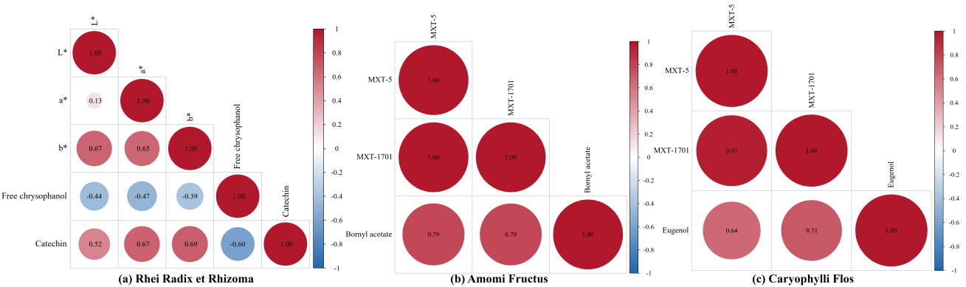
Figure S1. Pearson correlation heatmaps of raw sensor features and the target component for three additional datasets. (a) Rhei Radix et Rhizoma. (b) Amomi Fructus. (c) Caryophylli Flos. Color indicates the Pearson correlation coefficient $\text{r}$, and circle size indicates $\text{|}\text{r}\text{|}$.

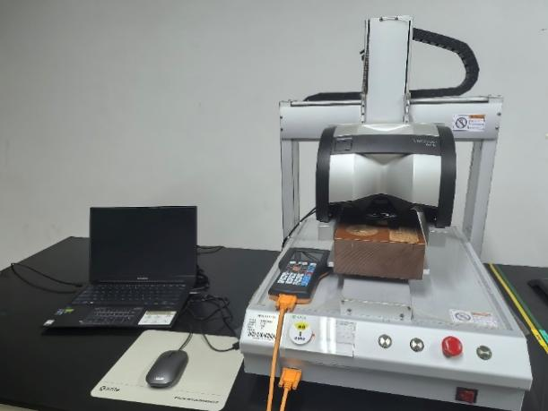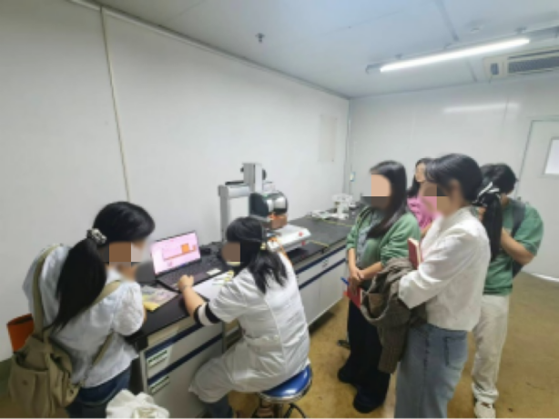
(a) (b)
Figure S2. Deployment of the TCM-USP prediction formulas in a practical rapid-testing scenario. (a) Electronic eye system used for color feature acquisition of Chinese medicinal materials. (b) On-site operation: quality control personnel acquiring sensor data and applying the explicit prediction formulas for preliminary content screening. Faces are obscured for privacy.

B. Supplementary tables
Table S1. Descriptive statistics of four additional medicinal material datasets used for supplementary validation.
Medicinal  Material | Sensor  Type | Raw  Features | Sample  Size | Target  Component | Mean | SD | CV | Skewness
Rhei Radix et Rhizoma-T | E-eye | 3 | 50 | Total rhein | 0.6091 | 0.3174 | 0.5211 | -0.4864
Scutellariae Radix | E-tongue | 7 | 50 | Baicalin | 14.4101 | 1.6507 | 0.1146 | -1.3649
Apocyni Veneti Folium | E-eye | 7 | 30 | Moisture content | 13.2779 | 1.4017 | 0.1056 | 0.3105
Corydalis Rhizoma | E-eye | 5 | 50 | Moisture-excluded | 0.1089 | 0.0287 | 0.2639 | -0.7457

Table S2. LOOCV performance comparison of all models on four supplementary datasets. The best results for each dataset are shown in bold.
Final Feature Expression | Type | Sensor Channels  Involved | Complexity  （C） | LOOCV  Frequency | Occurrence  Rate（%）
Rhei Radix et Rhizoma-T（E-eye, $\text{P} \text{=} \text{3}$, $\text{N} \text{=} \text{50}$, ${\text{n}}_{\text{comp}} \text{=} \text{2}$）
$$a$$ | Anchor | $$a$$ | 1 | 50/50 | 100.0
$$b/a$$ | Derived | $a$，$b$ | 3 | 45/50 | 90.0
$$b/L$$ | Derived | $b$，$L$ | 3 | 33/50 | 66.0
$$ln(|a|+1)/L$$ | Derived | $a$，$L$ | 3 | 12/50 | 24.0
Scutellariae Radix（E-tongue, $\text{P} \text{=} \text{7}$, $\text{N} \text{=} \text{50}$, ${\text{n}}_{\text{comp} }\text{=} \text{3}$）
$$\text{AHS}$$ | Anchor | $$\text{AHS}$$ | 1 | 50/50 | 100.0
$$ln(|PKS|+1)/AHS$$ | Derived | $$\text{PKS}\text{，}\text{AHS}$$ | 4 | 18/50 | 36.0
$$\text{ANS/}{\text{AHS}}^{\text{2}}$$ | Derived | $$\text{ANS}\text{，}\text{AHS}$$ | 4 | 15/50 | 30.0
$$ANS/ln(|PKS|+1)$$ | Derived | $$ANS，\text{PKS}$$ | 4 | 6/50 | 12.0
Apocyni Veneti Folium（E-eye, $\text{P} \text{=} \text{7}$, $\text{N} \text{=} \text{50}$, ${\text{n}}_{\text{comp}} \text{=} \text{1}$）
$$YI$$ | Anchor | $$YI$$ | 1 | 50/50 | 100.0
$$a$$ | Anchor | $$a$$ | 1 | 27/30 | 90.0
Corydalis Rhizoma（E-eye, $\text{P} \text{=} \text{5}$, $\text{N} \text{=} \text{50}$, ${\text{n}}_{\text{comp}} \text{=} \text{4}$）
$$L$$ | Anchor | $$L$$ | 1 | 50/50 | 100.0
$$b/a$$ | Derived | $a$，$b$ | 3 | 39/50 | 78.0
$$inv(b)$$ | Derived | $$b$$ | 2 | 31/50 | 62.0
$$inv(ISO)/ln(|a|+1)$$ | Derived | $\text{a}$，ISO | 5 | 13/50 | 26.0

Table S3. Final selected features and LOOCV stability for four supplementary datasets.
Final Feature Expression | Type | Sensor Channels  Involved | Complexity  （C） | LOOCV  Frequency | Occurrence  Rate（%）
Rhei Radix et Rhizoma-T（E-eye, $\text{P} \text{=} \text{3}$, $\text{N} \text{=} \text{50}$, ${\text{n}}_{\text{comp}} \text{=} \text{2}$）
$$a$$ | Anchor | $$a$$ | 1 | 50/50 | 100.0
$$b/a$$ | Derived | $a$，$b$ | 3 | 45/50 | 90.0
$$b/L$$ | Derived | $b$，$L$ | 3 | 33/50 | 66.0
$$ln(|a|+1)/L$$ | Derived | $a$，$L$ | 3 | 12/50 | 24.0
Scutellariae Radix（E-tongue, $\text{P} \text{=} \text{7}$, $\text{N} \text{=} \text{50}$, ${\text{n}}_{\text{comp} }\text{=} \text{3}$）
$$\text{AHS}$$ | Anchor | $$\text{AHS}$$ | 1 | 50/50 | 100.0
$$ln(|PKS|+1)/AHS$$ | Derived | $$\text{PKS}\text{，}\text{AHS}$$ | 4 | 18/50 | 36.0
$$\text{ANS/}{\text{AHS}}^{\text{2}}$$ | Derived | $$\text{ANS}\text{，}\text{AHS}$$ | 4 | 15/50 | 30.0
$$ANS/ln(|PKS|+1)$$ | Derived | $$ANS，\text{PKS}$$ | 4 | 6/50 | 12.0
Apocyni Veneti Folium（E-eye, $\text{P} \text{=} \text{7}$, $\text{N} \text{=} \text{50}$, ${\text{n}}_{\text{comp}} \text{=} \text{1}$）
$$YI$$ | Anchor | $$YI$$ | 1 | 50/50 | 100.0
$$a$$ | Anchor | $$a$$ | 1 | 27/30 | 90.0
Corydalis Rhizoma（E-eye, $\text{P} \text{=} \text{5}$, $\text{N} \text{=} \text{50}$, ${\text{n}}_{\text{comp}} \text{=} \text{4}$）
$$L$$ | Anchor | $$L$$ | 1 | 50/50 | 100.0
$$b/a$$ | Derived | $a$，$b$ | 3 | 39/50 | 78.0
$$inv(b)$$ | Derived | $$b$$ | 2 | 31/50 | 62.0
$$inv(ISO)/ln(|a|+1)$$ | Derived | $\text{a}$，ISO | 5 | 13/50 | 26.0

Table S4. Preliminary batch-level screening results for independent Fritillariae Ussuriensis Bulbus (FUB) and Schisandrae Chinensis Fructus (SCF) batches using TCM-USP prediction formulas.
ª Fritillariae Ussuriensis Bulbus (FUB): 50 validation batches independent of the 50 training samples. Reference values were determined by UV-Vis according to the Chinese Pharmacopoeia (2025 edition). The pharmacopoeial threshold for peiminine was 0.050%. A 20% screening margin was used for batch screening: predicted value$≥$0.060%, Pass; predicted value$≤$0.040%, Flag; predicted value $>$ 0.040% and $<$ 0.060%, Inconclusive (requires confirmatory testing).
^{b} Schisandrae Chinensis Fructus (SCF): 50 validation batches independent of the 43 training samples. Reference values were determined by HPLC according to the Chinese Pharmacopoeia (2025 edition).
The pharmacopoeial threshold for schisandrol A was 0.40%. A 10% screening margin was used for batch screening: predicted value $≥$ 0.44%, Pass; predicted value $≤$ 0.36%, Flag; predicted value $>$ 0.36% and $<$ 0.44% , Inconclusive (requires confirmatory testing). Batches CD-1 to CD-8 were subsequently identified as Schisandrae Sphenanthera Fructus, a different species not represented in the training data; therefore, their screening decisions were recorded as not applicable (N/A). Among the remaining 42 Schisandrae Chinensis Fructus batches, all absolute relative deviations were within 10%, and all were assigned Pass decisions consistent with the reference results.
Batch ID | Reference Value  (%) | Predicted Value  (%) | Relative Deviation  (%) | Screening Decision
Fritillariae Ussuriensis Bulbus ª
CD-1 | 0.16 | 0.23 | 16.86 | Pass
CD-2 | 0.19 | 0.17 | -7.61 | Pass
CD-3 | 0.25 | 0.23 | -3.28 | Pass
CD-4 | 0.23 | 0.23 | -0.37 | Pass
CD-5 | 0.28 | 0.26 | -4.14 | Pass
CD-6 | 0.11 | 0.10 | -5.21 | Pass
CD-7 | 0.24 | 0.17 | -17.43 | Pass
CD-8 | 0.17 | 0.15 | -6.93 | Pass
CD-9 | 0.28 | 0.19 | -19.66 | Pass
CD-10 | 0.21 | 0.27 | 13.23 | Pass
CD-11 | 0.17 | 0.16 | -2.97 | Pass
CD-12 | 0.19 | 0.17 | -4.10 | Pass
CD-13 | 0.20 | 0.15 | -13.55 | Pass
CD-14 | 0.15 | 0.10 | -18.00 | Pass
CD-15 | 0.18 | 0.15 | -10.52 | Pass
CD-16 | 0.29 | 0.21 | -15.43 | Pass
CD-17 | 0.15 | 0.16 | 3.21 | Pass
CD-18 | 0.20 | 0.13 | -18.82 | Pass
CD-19 | 0.16 | 0.15 | -2.64 | Pass
CD-20 | 0.14 | 0.18 | 12.12 | Pass
CD-21 | 0.15 | 0.19 | 11.89 | Pass
CD-22 | 0.14 | 0.16 | 4.38 | Pass
CD-23 | 0.21 | 0.25 | 7.97 | Pass
CD-24 | 0.24 | 0.27 | 4.65 | Pass
CD-25 | 0.20 | 0.17 | -7.69 | Pass
CD-26 | 0.31 | 0.25 | -10.45 | Pass
CD-27 | 0.22 | 0.25 | 5.42 | Pass
CD-28 | 0.31 | 0.28 | -3.58 | Pass
CD-29 | 0.17 | 0.12 | -18.40 | Pass
CD-30 | 0.25 | 0.25 | -1.89 | Pass
CD-31 | 0.35 | 0.28 | -10.79 | Pass
CD-32 | 0.27 | 0.25 | -4.47 | Pass
CD-33 | 0.25 | 0.27 | 4.21 | Pass
CD-34 | 0.15 | 0.15 | -1.85 | Pass
CD-35 | 0.24 | 0.24 | 1.37 | Pass
CD-36 | 0.13 | 0.15 | 6.67 | Pass
CD-37 | 0.28 | 0.19 | -18.19 | Pass
CD-38 | 0.17 | 0.24 | 16.45 | Pass
CD-39 | 0.16 | 0.18 | 7.14 | Pass
CD-40 | 0.18 | 0.16 | -6.32 | Pass
CD-41 | 0.12 | 0.15 | 9.75 | Pass
CD-42 | 0.15 | 0.16 | 5.14 | Pass
CD-43 | 0.28 | 0.28 | -0.03 | Pass
CD-44 | 0.19 | 0.17 | -6.50 | Pass
CD-45 | 0.18 | 0.24 | 14.95 | Pass
CD-46 | 0.18 | 0.14 | -11.64 | Pass
CD-47 | 0.13 | 0.16 | 10.51 | Pass
CD-48 | 0.28 | 0.24 | -8.00 | Pass
CD-49 | 0.20 | 0.16 | -12.37 | Pass
CD-50 | 0.15 | 0.16 | 3.91 | Pass
Schisandrae Chinensis Fructus ^{b}
CD-1 | 0.0099 | 27.0095 | 99.93 | N/A
CD-2 | 0.0484 | 19.5964 | 99.51 | N/A
CD-3 | 0.0118 | 2.5134 | 99.06 | N/A
CD-4 | 0.0158 | 0.8021 | 96.13 | N/A
CD-5 | 0.0190 | 0.4897 | 92.54 | N/A
CD-6 | 0.0254 | 0.8844 | 94.43 | N/A
CD-7 | 0.0288 | 0.7762 | 92.83 | N/A
CD-8 | 0.0264 | 0.4499 | 88.90 | N/A
CD-9 | 0.5756 | 0.6020 | 2.24 | Pass
CD-10 | 0.6174 | 0.6250 | 0.61 | Pass
CD-11 | 0.6122 | 0.6261 | 1.12 | Pass
CD-12 | 0.7707 | 0.7337 | 2.46 | Pass
CD-13 | 0.5971 | 0.6224 | 2.07 | Pass
CD-14 | 0.6254 | 0.6703 | 3.47 | Pass
CD-15 | 0.6006 | 0.5792 | 1.81 | Pass
CD-16 | 0.5990 | 0.5579 | 3.55 | Pass
CD-17 | 0.6158 | 0.6061 | 0.79 | Pass
CD-18 | 0.6347 | 0.6350 | 0.03 | Pass
CD-19 | 0.6836 | 0.6390 | 3.37 | Pass
CD-20 | 0.5892 | 0.6031 | 1.17 | Pass
CD-21 | 0.6151 | 0.6218 | 0.55 | Pass
CD-22 | 0.5822 | 0.6019 | 1.67 | Pass
CD-23 | 0.5538 | 0.5710 | 1.53 | Pass
CD-24 | 0.6492 | 0.6129 | 2.88 | Pass
CD-25 | 0.5895 | 0.5734 | 1.38 | Pass
CD-26 | 0.4764 | 0.5688 | 8.84 | Pass
CD-27 | 0.6439 | 0.6004 | 3.49 | Pass
CD-28 | 0.6019 | 0.6222 | 1.66 | Pass
CD-29 | 0.6462 | 0.6825 | 2.73 | Pass
CD-30 | 0.6622 | 0.5921 | 5.59 | Pass
CD-31 | 0.5430 | 0.6106 | 5.86 | Pass
CD-32 | 0.5734 | 0.5778 | 0.39 | Pass
CD-33 | 0.6616 | 0.5560 | 8.67 | Pass
CD-34 | 0.5604 | 0.5981 | 3.26 | Pass
CD-35 | 0.6015 | 0.6474 | 3.67 | Pass
CD-36 | 0.5944 | 0.6025 | -0.67 | Pass
CD-37 | 0.6633 | 0.6466 | 1.28 | Pass
CD-38 | 0.6426 | 0.6081 | 2.76 | Pass
CD-39 | 0.5495 | 0.5346 | 1.37 | Pass
CD-40 | 0.5261 | 0.5516 | 2.36 | Pass
CD-41 | 0.7706 | 0.6436 | 8.98 | Pass
CD-42 | 0.5437 | 0.5677 | 2.16 | Pass
CD-43 | 0.7673 | 0.7739 | 0.43 | Pass
CD-44 | 0.6407 | 0.6373 | 0.26 | Pass
CD-45 | 0.6042 | 0.5959 | 0.69 | Pass
CD-46 | 0.6032 | 0.6714 | 5.35 | Pass
CD-47 | 0.5889 | 0.5601 | 2.50 | Pass
CD-48 | 0.7234 | 0.6242 | 7.36 | Pass
CD-49 | 0.5783 | 0.6068 | 2.40 | Pass
CD-50 | 0.7631 | 0.7678 | 0.31 | Pass

